Preciosa Muujiza Ngoy Kalumba

The Hospital Administrator’s Database
1st version
Submittal date 09/22/2024

Table of Contents

The Hospital Administrator’s Database 0
Narrative Summary: 2
Requirement (Actors / Roles): 3
List of Entities: 3
List of Entities with Attributed nested 4
Business Rules (optionality, cardinality) 5
ERD 6
EERD 7

Narrative Summary:

The hospital administrator seeks to create a database to manage nurse assignments, patient care, and hospital operations. The database will record detailed information about nurses, including their names, contact details, medical specialties, and supervisory relationships. Nurses are assigned to wards, and their rotations are tracked by date and hours worked. Each ward has a charge nurse responsible for medical records, and information about each ward, such as its name, location, and phone number, will also be stored. Beds, categorized by size and type, are assigned to specific wards, with only one patient per bed at a time.

Patient details, including name, gender, date of birth, contact information, and admission/discharge dates, will be recorded, along with information about their admitting and discharging doctors. The database will also store doctor information, including contact details and medical specialties. Treatments administered to patients are tracked by name, description, charge, and results, with the date and time recorded. Patients may receive multiple treatments from different doctors.

In addition to treatments, the system will track charges for items used during a patient’s stay, including item name, date, quantity, and cost. Every patient incurs at least one charge for consumable items. Nurse-patient interactions, such as wellness checks, medication administration, and assistance, are recorded as events, capturing multiple interactions between patients and nurses during their stay. The database will help streamline the management of nurses, patients, beds, treatments, and hospital charges.

Requirement (Actors / Roles):

- Nurse: Nurses are assigned to wards and can rotate between them. They may also supervise other nurses or serve as charge nurses, responsible for maintaining medical records for a specific ward.
- Doctor: Admit and discharge patients, as well as administer treatments. Not all doctors admit patients, and not all administer treatments, but doctors are responsible for overseeing patient care when applicable.
- Patient: Receive care from nurses and treatments from doctors. Patients are admitted to the hospital, assigned beds, and incur charges for treatments and consumable items during their stay.
- Ward: Each ward is a physical space within the hospital with beds and assigned nurses. Beds and patient assignments are tracked, as well as the number of nurses working in each ward.
- Bed: Beds are assigned to patients and are linked to specific wards. Information about their availability and type (manual/electrical) is crucial for tracking patient assignments and care.
- Treatment: Administered to patients by doctors, includes tracking of name, description, charge, and results.
- Items (charged to patients): Consumables charged to patients during their stay, includes tracking of item name, charge, date, and quantity.

List of Entities:

- Nurse
- Doctor
- Patients
- Bed
- Ward
- Treatment
- Item

List of Entities with Attributed nested
- Nurse
  - Nurse ID (Primary Key)
  - Name
  - Address
  - Phone
  - Alternate Phone
  - Email
  - Specialties
  - Supervisor ID (Foreign Key, if applicable)
- Doctor
  - Doctor ID (Primary Key)
  - Name
  - Address
  - Phone
  - Alternate Phone
  - Email
  - Specialties
- Patients
  - Patient ID (Primary Key)
  - Name
  - Gender
  - Date of Birth
  - Address
  - Phone
  - Alternate Phone
  - Email
  - Admission Date
  - Discharge Date
  - Admitting Doctor ID (Foreign Key)
  - Discharging Doctor ID (Foreign Key)
- Bed
  - Bed ID (Primary Key)
  - Ward ID (Foreign Key)
  - Size (small, large, extra-large)
  - Type (manual, electric)
  - Availability Status
- Ward
  - Ward ID (Primary Key)
  - Ward Number
  - Descriptive Name
  - Physical Location
  - Phone Number
- Treatment
  - Treatment ID (Primary Key)
  - Name
  - Description
  - Charge
  - Date Administered
  - Time Administered
  - Results
  - Patient ID (Foreign Key)
  - Treating Doctor ID (Foreign Key)
- Item
  - Item ID (Primary Key)
  - Name
  - Charge
  - Date Charged
  - Quantity
  - Patient ID (Foreign Key)

Business Rules (optionality, cardinality)
Nurse:
- A nurse must be assigned to at least one ward (mandatory) but can rotate between multiple wards (one-to-many).
- A nurse can supervise one or more other nurses, but not all nurses supervise others (optional, one-to-many).
- A nurse may have a supervisor, but a nurse is supervised by only one nurse (optional, many-to-one).
- A nurse may act as a charge nurse for a ward, but not all nurses do (optional, one-to-one).
Doctor:
- A doctor can admit multiple patients (optional, one-to-many).
- A doctor may or may not administer treatments to patients (optional, many-to-many).
- A doctor may discharge multiple patients (optional, one-to-many)
Patients:
- A patient must be assigned to a bed (mandatory, one-to-one).
- A patient can be admitted by only one doctor but may receive treatment from multiple doctors (mandatory, many-to-one for admission, many-to-many for treatments).
- A patient must have at least one treatment or charge (mandatory, one-to-many).
- A patient may interact with multiple nurses during their stay (many-to-many).
Bed:
- A bed must be assigned to one patient at a time (mandatory, one-to-one).
- A bed belongs to one specific ward (mandatory, many-to-one).
Ward:
- A ward must have at least one nurse assigned to it at any given time (mandatory, one-to-many).
- A ward must have one charge nurse (mandatory, one-to-one).
- A ward contains multiple beds (mandatory, one-to-many).
Treatment:
- A treatment can be administered to one or more patients (many-to-many).
- A treatment must be performed by a doctor (mandatory, many-to-one).
- A treatment is optional for a patient (optional, many-to-many).
Item:
- An item must be charged to at least one patient (mandatory, many-to-many).
- A patient can incur charges for multiple items during their stay (mandatory, one-to-many).

ERD

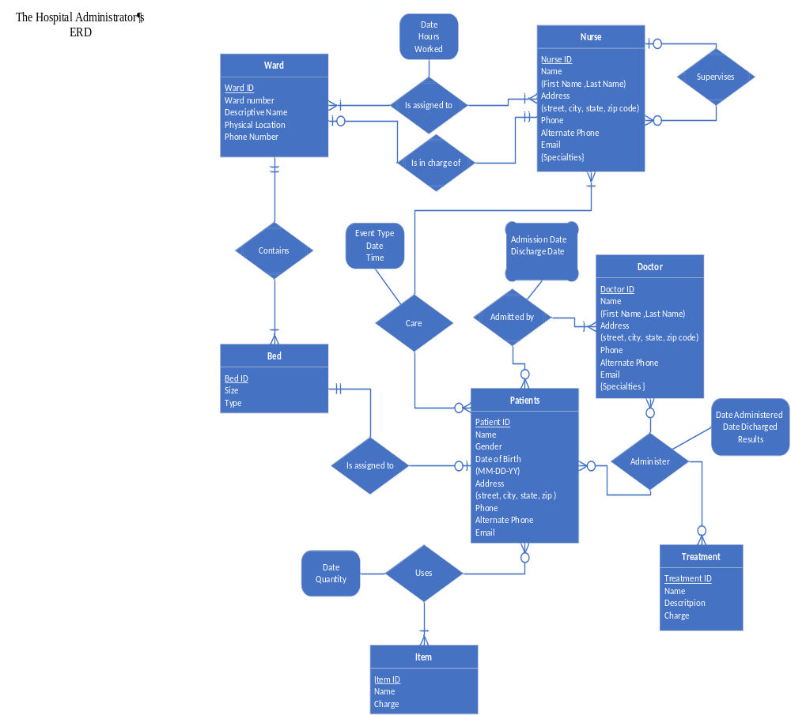

EERD

